Press Release
19. February 2024

Collaboration between DMG MORI and FOBA
FOBA Laser Marking + Engraving is part of the DMG MORI process chain with a marking workstation of the FOBA M-Series, which was presented at the EMO in Hanover and can now be seen in the showroom of the DMG MORI Academy GmbH in Bielefeld. Machining Transformation (MX) from DMG MORI combines the four pillars of Process Integration, Automation, Digital Transformation (DX) and Green Transformation (GX) for modern and sustainable manufacturing. In the series production of the Robo2Go head, DMG MORI uses the full potential of process integration - 3D printing, automated complete machining, digitalization - at all levels.
Bielefeld, February 2024 - DMG MORI has developed a process chain for its in-house showroom in Bielefeld. The idea behind it is to create real production conditions in order to make the added value of digitalized manufacturing processes tangible for customers. This makes every production step comprehensible – from the raw material to the finished product. At the same time, the green transformation is promoted through increased productivity, reduced energy consumption and careful use of resources.
The process chain starts with the 3D printing of an aluminum robot head and is exemplary for many possible applications in industrial production. The robot head is then provided with a sticker containing order information. This label cannot remain on the component during the subsequent production process, as it would no longer be securely legible after CNC machining with cooling lubricant. A solution therefore had to be found for permanent and reliable identification of the robot head, and this is where DMG MORI called in the laser marking experts from FOBA.

Dr. Rinje Brandis, General Manager Additive Manufacturing and Industry 4.0 ADDITIVE INTELLIGENCE at DMG MORI Academy GmbH, explains why FOBA was chosen: "We were looking for a partner that has extensive expertise in this area and can support us with marking and integration into the digital process chain."
For Christian Söhner, Global Vertical Manager Medical at FOBA, this type of collaboration and the topics that are implemented with the process chain fit in with FOBA's focus: "Process integration, automation and digitalization are topics that play a central role at FOBA. That's why we were immediately enthusiastic when we heard about the idea of the process chain. This proximity to industry means we always have an eye on what moves our customers. In this way, we develop pioneering solutions for product marking that are adapted to the needs of the industry and are therefore able to respond flexibly to individual requirements."

In the FOBA M2000-P laser marking workstation, the robot heads are marked with the company logo, the serial and product number and the customer's component number. The digital production file can also be read using a DataMatrix code. Further processing steps follow in the process chain, such as milling, wire erosion and a 3D scan.

The process chain – which is permanently on display in the DMG MORI showroom in Bielefeld – was also shown at EMO Hanover, the world's leading trade fair for production technology, in the DMG MORI City, which covered an area of around 9,000 m².

About DMG MORI:
DMG MORI is a leading global manufacturer of machine tools and drives holistic process integration based on technology integration, automation and digitization for greater sustainability. In the "Global One Company", more than 12,000 employees work together to be a total solution provider for our customers. DMG MORI is represented in 43 countries worldwide - with 16 production sites and 113 sales and service locations.
High-precision machine tools and sustainable technologies are at the beginning of global value chains. Integrated automation and end-to-end digitization solutions extend our core business with turning and milling machines, Advanced Technologies and Additive Manufacturing. Our technology excellence is bundled within the main sectors of Aerospace, Automotive, Die & Mold as well as Medical and Semiconductor.
dmgmori.com

About FOBA Laser Marking + Engraving
FOBA Laser Marking + Engraving (brand of ALLTEC Angewandte Laserlicht Technologie GmbH) is one of the leading manufacturers and providers of innovative laser marking solutions. FOBA's marking lasers, laser marking machines and imaging marking workflows are used primarily in the automotive supply industry, medical technology, electronics and plastics industry as well as in tool, metal and mold making for marking a wide range of materials and products. A worldwide sales organization as well as international sales partners and service locations serve the global markets.
fobalaser.com

Images for editorial use

Images can be downloaded free of charge for editorial use at: https://www.fobalaser.com/newsroom-events/news-press/collaboration-between-dmg-mori-and-foba/

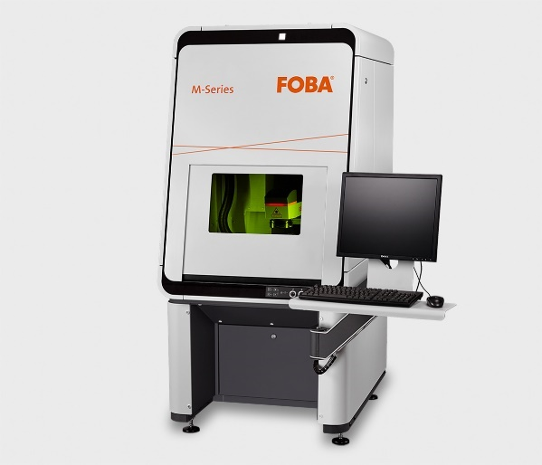

The FOBA M2000 marking workstation is classified in laser protection class 1 and is part of the DMG MORI process chain. (Copyright: FOBA)

For additional information and images for editorial use please contact:

Kathrin Urban | Campaign & Event Manager
ALLTEC Angewandte Laserlicht Technologie GmbH | FOBA Laser Marking + Engraving
An der Trave 27 – 31 | 23923 Selmsdorf
Tel.: +49 (0)38823 55-440
kathrin.urban@fobalaser.com | www.fobalaser.com

