Media Release
18. Oktober 2023

Three in one - FOBA presents new compact V-Series at productronica 2023

Minimal space requirements and three wattages in one - FOBA presents the next generation of V-series live at productronica in Munich from November 14-17, 2023. The easy and space-saving integration of the multifunctional UV and green laser head will be the main topic at the FOBA booth in hall B2, booth 207.

Selmsdorf, October 2023 - At productronica, one of the world's most important leading trade fairs for development and manufacturing, FOBA presents the compact laser workstation M1000 with integrated 3W UV / 5W UV / 10W green laser. All three wattages are combined in one product to achieve minimum space requirements with maximum flexibility.
"Our customers have signaled that saving space in production is an important issue for them. Therefore, we are very pleased to introduce this next generation of the FOBA V-Series - so compact that the laser head fits into our smallest laser workstation," says Philipp Febel, Director Product Management. Due to the wavelength and the corresponding low heat input during marking, 355 and 532 nm lasers are ideally suited for high-contrast laser marking of delicate and sensitive materials, such as plastics, glass or ceramics.
The FOBA team will also bring innovative software solutions with them. Visitors will be able to see a live demonstration of the Mosaic software feature on the FOBA M2000 stand-alone laser marking machine. FOBA Mosaic enables marking without a fixture - regardless of their position under the marking laser. This allows components to be precisely marked completely independently of their placement in the laser marking machine.

Visitors to the trade fair will find the FOBA booth in Hall 2 at Stand 207. Interested parties can arrange an individual consultation appointment and receive a free trade fair ticket at info@fobalaser.com.

Further information:
Productronica 2023 - World's Leading Trade Fair for the Development and Manufacture of Electronics
November 14-17, 2023 | Munich Trade Fair Center
https://productronica.com/en/

FOBA Laser Marking + Engraving
https://www.fobalaser.com/

Images for editorial use:

Images to download for editorial use at: https://www.fobalaser.com/newsroom-events/news-press/new-compact-v-series-at-productronica-2023

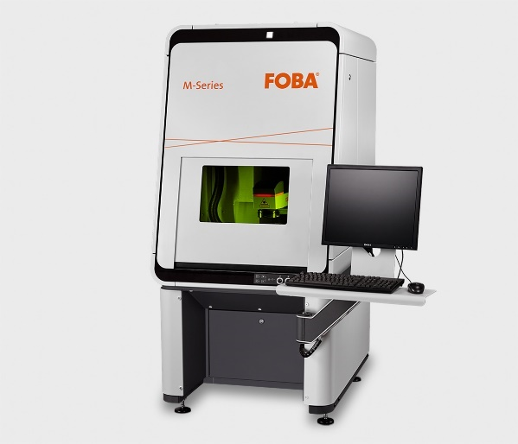

The FOBA M2000 marking workstation is classified in laser protection class 1 and is optionally equipped with the Mosaic marking function. (Copyrights: FOBA)
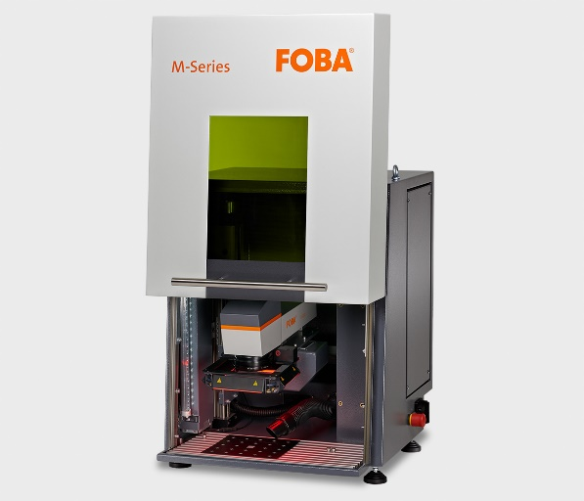
Compact laser marking unit FOBA M1000, in which a FOBA UV laser can be integrated.
(Copyright: FOBA)

Weitere Informationen sowie Text- und Bildmaterial erhalten Sie von:
For additional information and images for editorial use please contact:

Kathrin Urban | Campaign & Event Manager
ALLTEC Angewandte Laserlicht Technologie GmbH | FOBA Laser Marking + Engraving
An der Trave 27 – 31 | 23923 Selmsdorf
Tel.: +49 (0)38823 55-440
kathrin.urban@fobalaser.com | www.fobalaser.com

Über FOBA www.fobalaser.com/de/
FOBA Laser Marking + Engraving (Marke der ALLTEC Angewandte Laserlicht Technologie GmbH) ist einer der führenden Hersteller und Anbieter von innovativen Lasermarkierlösungen. FOBAs Beschriftungslaser, Lasermarkiermaschinen und bildgebende Kennzeichnungsworkflows kommen vor allem in der Automobilzulieferindustrie, Medizintechnik, Elektronik und Kunststoffindustrie sowie im Werkzeug-, Metall- und Formenbau zur Kennzeichnung einer Vielzahl an Materialien und Produkten zum Einsatz. Ein weltweiter Vertrieb sowie internationale Vertriebspartner und Servicestandorte bedienen die globalen Märkte. Seit 2004 gehört ALLTEC/FOBA mit der Firmenzentrale in Selmsdorf bei Lübeck zur US-amerikanischen Veralto Corporation.

About FOBA www.fobalaser.com
FOBA Laser Marking + Engraving (brand of ALLTEC Angewandte Laserlicht Technologie GmbH) is one of the leading suppliers of advanced laser marking systems. FOBA develops and manufactures marking lasers for integration as well as laser marking workstations with vision assisted marking workflows. FOBA technology is being applied for the direct part marking of any kind of metals, plastics, or other materials in industries like automotive, medical, electronics, plastics or tool, metal and mold making. With its worldwide sales and service branches and its headquarters near Lübeck/Hamburg (Germany) ALLTEC/FOBA is part of the Veralto Corporation.

